**A PROJECT REPORT**

**ON**

***SMART METERING USING E-WALLET***

**A Dissertation submitted in partial fulfillment**

**DIPLOMA IN COMPUTER ENGINEERING**

**AFFILIATED TO MSBTE**



**Submitted by**

**Utkarsh Bhangale**

**Vinay Sudrik**

**Sumit Bhattacharya**

**Prafful Wania**

**Under the guidance of**

**Mrs. Nilam Jadhav**

**DEPARTMENT OF COMPUTER ENGINEERING**

**PIMPRI CHINCHWAD POLYTECHNIC**

**AKURDI, PUNE 2017-2018**

**PIMPRI CHINCHWAD EDUCATION TRUST’S**

**PIMPRI CHINCHWAD POLYTECHNIC**

**DEPARTMENT OF COMPUTER ENGINEERING**

**PRADHIKARAN, AKURDI, PUNE-411044.**

**C E R T I F I C A T E**

This is to certify that

The end term Project report entitled

**SMART METERING USING E-WALLET**

Has been completed successfully by-

**Utkarsh P. Bhangale – 36**

**Vinay Sudrik – 46**

**Sumit Bhattacharya – 16**

**Prafful Wania – 50**

Mrs. Nilam Jadhav Prof. M.S.Malkar Prof. V.S. Byakod

Project Guide H.O.D Principal

(External Examiner) Seal of Institute

**Maharashtra State Board of Technical Education for**

**Academic Year 2017-2018**

**ACKNOWLEDGEMENT**

It gives us great pleasure that we have completed our project work in the stipulated time frame. The project, which is the part of our final year Diploma syllabus, gave us some anxious as well as very exhilarator experience throughout its period. The project we selected was “SMART METERING USING E-WALLET”.

The success of any project is never limited to the individuals undertaking the projects. It is the collective efforts of the people around, that spell success. This Acknowledgement is a humble attempt of earnestly thanking all those who were directly or indirectly involved in our project. The desired to have best and get closer to perfection has made us to try to achieve the perfection.

Ability and ambition are not enough for success. Success of any project depends solely on support, guidance, encouragement received from the guides and parent’s well wishes. We would like to express our sincere gratitude to our honourable Principal, ***Prof.Mrs.V.S.Byakod.*** For her constant support and encouragement.

We would like to extend our sincere, heartfelt gratitude to our Head of Department, ***Prof.Mrs.M.S.Malkar*,** and our internal project guide ***Mrs.Nilam Jadhav.*** Under whose guidance we had the privilege of doing this work and whose constant inspiration at all faces of the project, lead to our successful completion of work. Last but not the least, we express our deepest regards to all staff members and lab assistants, for helping us and providing all required facilities.

|  |  |  |
| --- | --- | --- |
| Roll No. | Name | Sign |
| 36 | Utkarsh Bhangale |  |
| 46 | Vinay Sudrik |  |
| 50 | Prafful wania |  |
| 16 | Sumit Bhattacharya |  |

**ABSTRACT**

In old days, there existed electricity meters but which work on some metallic strip like mechanism thus had a disadvantage of freezing the meter with the use of magnet. To overcome this problem new meters came which is still used since like from 2000. One thing was sure no one was able to **freeze** the reading meter installed in the current electricity meter. Thus it is a successful prototype.

The Existing domestic Energy meter reading systems universally exist many problems, such as difficulty in construction, too narrow bandwidth, too low rate, poor real time, not two way communication quickly etc. To solve above problems, this paper uses the wireless technology for Automatic Meter Reading system. A proposed method provides the communication between the Electricity Board section and the consumer section using Internet of things (IOT) for transmitting the customer’s electricity consumption and bill information that is calculated using ARM7 microcontroller. The power fluctuations are monitored using the voltage sensor and current sensor are fed to the microcontroller which indicates it to the Electricity Board. Depending on the power generation, the house hold devices are controlled automatically. From Electricity Board section the information regarding the bill amount and payment are communicated to the consumer via Global System for Mobile communication. The power and billing information is continuously transmitted by the use of Internet of Things and monitored by the Electricity Board section. Design and implementation of project is mainly based on ARM controller using IOT concept.

There is unusual work load on people who come to collect the reading of the electricity meter. Also no new paying system is generated. There is **payment** done **online** but after when a person checks the reading at the month end and our bill is generated. To overcome this we made this prototype called as Smart Electricity Meter. In which we added some extra features and also implemented **IoT (Internet of Things)**. In our module we installed **Arduino** **board** which is like the brain of this meter handles the transaction and messaging functions. The Smart Electricity Meter helps us to reduce unusual workload on workers of the **MSEB**. Thus saving time and money. It has a unique system which calculates the money and energy and generates a bill which is then sent through message to MSEB and to the **OWNER** of the meter.

**CONTENTS**

|  |  |  |
| --- | --- | --- |
| **SR. NO** | **CHAPTER** | **PAGE NO** |
| 1. | INTRODUCTION | 1 |
| 2. | PROPOSED WORK | 4 |
| 3. | SYSTEM DESCRIPTION  MODULES | 11 |
| 4. | WORKING AND ANALYSIS | 34 |
| 5. | IMPLEMENTATION | 36 |
| 6. | CONCLUSION & FUTURE SCOPE | 48 |
| 7. | ANNEXURE A | 50 |
| 8. | ANNEXURE B | 55 |
| 9. | ANNEXURE C | 58 |

**SMART METERING USING E-WALLET**

**CHAPTER 1: INTRODUCTION**

**INTRODUCTION**

**1.1 Background**

The increasing generation needs empowered gadgets by wireless technology which includes Bluetooth, Radio Frequency Identification, Embedded sensors and many more. In that IOT technology has grown from its beginning and now presently widely using it. The electricity plays an important role in our life. Now-a-days as the consumers are increasing rapidly it became very hard to handle the electricity requirements. Without electricity it’s impossible to survive and also it is important to save the electricity loss. As the generation is increases the consumer’s requirements also increasing so in accordance with it the technology improvement is needed. So we developed the system with faster and improved technology i.e. IOT. The electricity also contains some issues like power theft. Power theft is a measure crime and it also directly affects the economy of our country. Transmission, generation and distribution of electricity include the loss of electricity. To avoid the losses we need to monitor the power consumption and losses, so that we can efficiently utilize the generated power. Meter tempering is part of power theft and also illegal crime which we can minimize. Billing is a process in general the human operator goes to every consumer’s home then providing bill it will take lot of time. To resolve these issues we developed system on the base of IOT energy meter reading. Where all the information can send through this controller to the other part of the system. Once the information is sent the ARM 7 controller it will further communicate to Arduino and it will display on the LCD. And the programming of the whole system is done using embedded ‘c’.

**1.2 Motivation**

We can see a person standing in front of our house from electricity board, whose duty is to read the energy meter and handover the bills to the owner of that house every month. This is nothing but meter reading. According to that reading we have to pay the bills. The main drawback of this system is that person has to go area by area and he has to read the meter of every house and handover the bills. Many times errors like extra bill amount, or notification from electric board even though the bills are paid are common errors. To overcome this drawback we have come up with an idea which will eliminate the third party between the consumer and service provider, even the errors will be overcome. The idea of smart energy meter using IoT and Arduino have been introduced. In this method we are using Arduino because it is energy efficient i.e. it consume less power, it is fastest.

In the present billing system the distribution companies are unable to keep track of the changing maximum demand of consumers. The consumer is facing problems like receiving due bills for bills that have already been paid as well as poor reliability of electricity supply and quality even if bills are paid regularly. The remedy for all these problems is to keep track of the consumers load on timely basis, which will held to assure accurate billing, track maximum demand and to detect threshold value. These are all the features to be taken into account for designing an efficient energy billing system.

Energy meters which is already installed at our houses are not replaced, but a small modification on the already installed meters can change the existing meters into smart meters. The use of GSM module provides a feature of notification through SMS.

**1.3 Need**

This system enables the electricity department to read the meter readings monthly without a person visiting each house. This can be achieved by the use of Arduino unit that continuously monitor and records the energy meter reading in its permanent (non-volatile) memory location. This system continuously records the reading. This system also can be used to disconnect the power supply of the house when needed.

**1.4 Objective**

The main objective is to automate the manual process of taking readings, calculating bills and then handing them to the user. All the process from calculating the exact use of electricity to paying the Bills to MSEB is made digital and can be automated. The main objective is to make the work of MSEB easier and hustle free.

**1.5 Literature Survey**

Through a brief review of the published literature and previously done work, we can say that the researches have done a severe work on the plc power line communication and Internet of Things (IoT). It is concluded from the ken study of their work that in today`s world PLC & IoT based meter could improve the overall efficiency of the existing or present system and could help in examining the unnecessary losses of power in different areas.

[1] Sudhish N George and Ashna K, GSM based automatic

energy meter reading system with instant billing, IEEE

publications for International Multi-Conference on

Automation, Computing, Communication, Control and

Compressed Sensing(iMac4s), 2013 ,March 2013, pp. 65-

71.

[2] Syed Khizar Ali Zaidi, Design and implementation of low

cost electronic prepaid energy meter, Proceedings of the

12th IEEE International Multitopic Conference,

December 23-24,2008, pp 548-552.

[3] H G Rodney Tan,C H Lee and V H Mok, Automatic power

meter reading system using GSM network ,The 8th

International Power Engineering Conference (IPEC

2007) , pp. 465-469.

[4] A Geetha and Dr.K Jamuna, Smart metering system

International Conference on Information

Communication and Embedded Systems (ICICES), 2013,

pp 1-5.

[5] Arghya Sarkar and S. Sengupta, A novel instantaneous

power factor measurement method based on wavelet

transform, IEEE Power India Conference, 2006,pp 1-6.

**CHAPTER 2: PROPOSED WORK**

**2.1 Scope of the project**

* The system will be used to provide bill to consumer both as an SMS along with other in-built features such as tamper proof, fault detection.
* The proposed energy meter utilizes a GSM module to transfer energy consumed to the authority side.
* Similarly authority side also uses these GSM service to send back the bill.
* Electricity bill will be automatically deducted from E-Wallet.
* Customers can recharge their meter through E-Wallet Facility.

**2.2 Existing System**

In the present billing system the distribution companies are unable to keep track of the changing maximum demand of consumers. The consumer is facing problems like receiving due bills for bills that have already been paid as well as poor reliability of electricity supply and quality even if bills are paid regularly.

* 1. **Requirements**

**2.3.1 Software Requirements**

* Arduino IDE
* Embedded C Programming Language
  + 1. **Hardware Requirements**
* Arduino Nano AT mega 328 Microcontroller
* Current Sensor
* GSM Modem
* LCD Display
* Energy Meter
* Loads
* Resisters
* Capacitors
* Diodes

**2.4 Advantages**

* Eliminates manual monthly meter readings
* Monitors the electric system much more quickly
* Makes it possible to use power resources more efficiently
* Provides real-time data that is useful for balancing electric loads while reducing power outages (i.e., blackouts)
* Enables dynamic pricing, which raises or lowers the cost of electricity based on demand

**2.5 Disadvantages**

* Exposure of sensitive customer data.
* Connectivity to untrustworthy partners that cannot be selected.
* Exposure of critical infrastructure due to connectivity reasons.

**2.6 Problem Definition**

* Avoid the possibility of hacking the system, and basically, taking free electricity.
* To prevent meter tempering.
* Real-time Models and design methods describing reliable interworking of heterogeneous systems (e.g. technical/economical/ social/environmental systems).
* To reduce the human efforts, and to cut the power automatically if the bill is not paid**.**

**2.7 Risk Management**

**What is Risk?**

“Risk is future uncertain events with a probability of occurrence and a potential for loss” Risk identification and management are the main concerns in every software project. Effective analysis of software risks will help to effective planning and assignments of work.

Categories of risks:

1. Schedule Risk:  
 Project schedul11e get slip when project tasks and schedule release risks are not addressed properl1y.Schedule risks mainly effect on project and finally on company economy and may lead to project failure. Schedules often slip due to following reasons:

Wrong time estimation

* Resources are not tracked properly. All resources like staff, systems, skills of individuals etc.
* Failure to identify complex functionalities and time required to develop those functionalities.
* Unexpected project scope expansions.

2. Budget Risk:

* Wrong budget estimation.
* Cost overruns
* Project scope expansion

3. Operational Risks:  
 Risks of loss due to improper process implementation, failed system or some external events risks.  
Causes of Operational risks:

* Failure to address priority conflicts
* Failure to resolve the responsibilities
* Insufficient resources
* No proper subject training
* No resource planning

4. Technical risks:  
 Technical risks generally leads to failure of functionality and performance.  
Causes of technical risks are:

* Continuous changing requirements
* No advanced technology available or the existing technology is in initial stages.
* Product is complex to implement.
* Difficult project modules integration.

5. Programmatic Risks: -  
 These are the external risks beyond the operational limits. These are all uncertain risks are outside the control of the program.  
These external events can be:

* Running out of fund.
* Market development
* Changing customer product strategy and priority.

Due to series of high-profile business scandals and failures, electronic theft and increased regulatory requirements, the need for risk management has increased dramatically. Risk management is the process of identifying, assessing, and taking steps to reduce risks to an acceptable level. The management of an organization must ensure that the organization has the capabilities required to accomplish its mission. The leadership of an organization is responsible and accountable for reducing the level of risk exposure to a pre-set level which the organization is willing to accept in the context of

Real world threats. A risk management process allows managers to balance the costs of protective measures with the benefits. If a company is not aware of their risks and consequently is not able to deal with the risks, this might eventually result in undesirable outcomes. These implications can be categorized as technical, financial and social implications. For example; fraud in the billing process can have an effect on the turnover of an electricity distributing company. The loss in return can be millions of Rupees. In every organization, methods, procedures and guidelines are available for risk management, however, not always the correct risks are managed. It might be the case that the internal control system of an organization is not in line with the risk profile of the organization. Enterprise Risk Management (ERM) provides a solution for this problem. ERM refers to the methods and processes used by organizations to manage risks or seize opportunities related to the achievement of their objectives. In contrast with traditional risk management methods, ERM provides organizations the opportunity to react proactively against changing circumstances. The risk profile of a company will be monitored constantly, so the internal controls can be changed continuously as a reaction to changing circumstances and the company will be always ‘in-control’. Possible events and related risks are noticed in an early stage and the organization will be able to act and to change the system of internal control in an adequate manner.

**Life Cycle of Project**

The **systems development life cycle** (**SDLC**), also referred to as the **application development life-cycle**, is a term used in systems engineering, information systems and software engineering to describe a process for planning, creating, testing, and deploying an information system. The systems development life-cycle concept applies to a range of hardware and software configurations, as a system can be composed of hardware only, software only, or a combination of both.

A systems development life cycle is composed of a number of clearly defined and distinct work phases which are used by systems engineers and systems developers to plan for, design, build, test, and deliver information systems. Like anything that is manufactured on an assembly line, an SDLC aims to produce high-quality systems that meet or exceed customer expectations, based on customer requirements, by delivering systems which move through each clearly defined phase, within scheduled time frames and cost estimates. Computer systems are complex and often link multiple traditional systems potentially supplied by different software vendors. To manage this level of complexity, a number of SDLC models or methodologies have been created.

The system development life cycle framework provides a sequence of activities for system designers and developers to follow. It consists of a set of steps or phases in which each phase of the SDLC uses the results of the previous one.

The SDLC adheres to important phases that are essential for developers, such as planning, analysis, design, and implementation, and are explained in the section below. It includes evaluation of present system, information gathering, and feasibility study and request approval. A number of SDLC models have been created: waterfall, fountain, spiral, build and fix, rapid prototyping, incremental, synchronize and stabilize. The oldest of these, and the best known, is the waterfall model: a sequence of stages in which the output of each stage becomes the input for the next. These stages can be characterized and divided up in different ways, including the following:

* **Preliminary analysis**: The objective of phase 1 is to conduct a preliminary analysis, propose alternative solutions, describe costs and benefits and submit a preliminary plan with recommendations.

1. Conduct the preliminary analysis: in this step, you need to find out the organization's objectives and the nature and scope of the problem under study. Even if a problem refers only to a small segment of the organization itself, you need to find out what the objectives of the organization itself are. Then you need to see how the problem being studied fits in with them.
2. Propose alternative solutions: In digging into the organization's objectives and specific problems, you may have already covered some solutions. Alternate proposals may come from interviewing employees, clients, suppliers, and/or consultants. You can also study what competitors are doing. With this data, you will have three choices: leave the system as is, improve it, or develop a new system.
3. Describe the costs and benefits.

* **Systems analysis, requirements definition**: Defines project goals into defined functions and operation of the intended application. It is the process of gathering and interpreting facts, diagnosing problems and recommending improvements to the system. Analyzes end-user information needs and also removes any inconsistencies and incompleteness in these requirements.

A series of steps followed by the developer are:

1. Collection of Facts: End user requirements are obtained through documentation, client interviews, observation and questionnaires,
2. Scrutiny of the existing system: Identify pros and cons of the current system in-place, so as to carry forward the pros and avoid the cons in the new system.
3. Analyzing the proposed system: Solutions to the shortcomings in step two are found and any specific user proposals are used to prepare the specifications.

* **Systems design**: Describes desired features and operations in detail, including screen layouts, business rules, process diagrams, pseudo code and other documentation.
* **Development**: The real code is written here.
* **Integration and testing**: Brings all the pieces together into a special testing environment, then checks for errors, bugs and interoperability.
* **Acceptance, installation, deployment**: The final stage of initial development, where the software is put into production and runs actual business.
* **Maintenance**: During the maintenance stage of the SDLC, the system is assessed to ensure it does not become obsolete. This is also where changes are made to initial software. It involves continuous evaluation of the system in terms of its performance.
* **Evaluation**: Some companies do not view this as an official stage of the SDLC, while others consider it to be an extension of the maintenance stage, and may be referred to in some circles as post-implementation review. This is where the system that was developed, as well as the entire process, is evaluated. Some of the questions that need to be answered include: does the newly implemented system meet the initial business requirements and objectives? Is the system reliable and fault-tolerant? Does the system function according to the approved functional requirements? In addition to evaluating the software that was released, it is important to assess the effectiveness of the development process. If there are any aspects of the entire process, or certain stages, that management is not satisfied with, this is the time to improve. Evaluation and assessment is a difficult issue. However, the company must reflect on the process and address weaknesses.
* **Disposal:** In this phase, plans are developed for discarding system information, hardware and software in making the transition to a new system. The purpose here is to properly move, archive, discard or destroy information, hardware and software that is being replaced, in a manner that prevents any possibility of unauthorized disclosure of sensitive data. The disposal activities ensure proper migration to a new system. Particular emphasis is given to proper preservation and archival of data processed by the previous system. All of this should be done in accordance with the organization's security requirements.

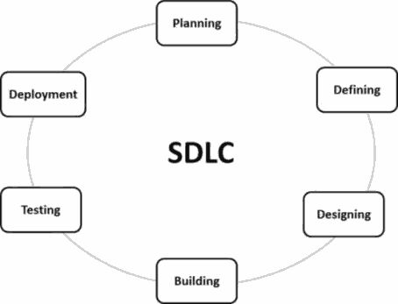

Fig. System design life cycle

**CHAPTER 3: SYSTEM DESCRIPTION**

**PROJECT MODULES**

**MODULES**

3.1 TRANSFORMER 230v-AC

A **transformer** is a static electrical device that transfers electrical energy between two or more circuits through electromagnetic induction. A varying current in one coil of the transformer produces a varying magnetic field, which in turn induces a varying electromotive force (EMF) or "voltage" in a second coil. Power can be transferred between the two coils through the magnetic field, without a metallic connection between the two circuits. Faraday's law of induction discovered in 1831 described this effect. Transformers are used to increase or decrease the alternating voltages in electric power applications.

Since the invention of the first constant-potential transformer in 1885, transformers have become essential for the transmission, distribution, and utilization of alternating current electrical energy.[3] A wide range of transformer designs is encountered in electronic and electric power applications. Transformers range in size from RF transformers less than a cubic centimeter in volume to units interconnecting the power grid weighing hundreds of tons.

Referring to the two schematic models pictured below, an ideal transformer is a theoretical, linear transformer that is lossless and perfectly coupled. Perfect coupling implies infinitely high core magnetic permeability and winding inductances and zero net magneto motive force.

A varying current in the transformer's primary winding creates a varying magnetic flux in the transformer core and a varying magnetic field impinging on the secondary winding. This varying magnetic field at the secondary winding induces a varying EMF or voltage in the secondary winding due to electromagnetic induction. The primary and secondary windings are wrapped around a core of infinitely high magnetic permeability[e] so that all of the magnetic flux passes through both the primary and secondary windings. With a voltage source connected to the primary winding and load impedance connected to the secondary winding, the transformer currents flow in the indicated directions. (See also Polarity.)

According to Faraday's law, since the same magnetic flux passes through both the primary and secondary windings in an ideal transformer, a voltage is induced in each winding, according to eq. (1) in the secondary winding case, according to eq. (2) in the primary winding case. The primary EMF is sometimes termed counter EMF. This is in accordance with Lenz's law, which states that induction of EMF always opposes development of any such change in magnetic field.

The transformer winding voltage ratio is thus shown to be directly proportional to the winding turns ratio according to eq. Common usage having evolved over time from 'turn ratio' to 'turns ratio'. However, some sources use the inverse definition.

According to the law of conservation of energy, any load impedance connected to the ideal transformer's secondary winding results in conservation of apparent, real and reactive power consistent with

The ideal transformer identity is a reasonable approximation for the typical commercial transformer, with voltage ratio and winding turns ratio both being inversely proportional to the corresponding current ratio.

By Ohm's law and the ideal transformer identity:

* the secondary circuit load impedance can be expressed as eq. (6)
* The apparent load impedance *referred* to the primary circuit is derived in eq. (7) to be equal to the turns ratio squared times the secondary circuit load impedance.

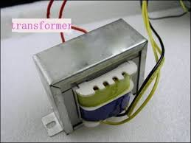

3.2 RELAY

A **relay** is an electrically operated switch. Many relays use an electromagnet to mechanically operate a switch, but other operating principles are also used, such as solid-state relays. Relays are used where it is necessary to control a circuit by a separate low-power signal, or where several circuits must be controlled by one signal. The first relays were used in long distance telegraph circuits as amplifiers: they repeated the signal coming in from one circuit and re-transmitted it on another circuit. Relays were used extensively in telephone exchanges and early computers to perform logical operations.

A type of relay that can handle the high power required to directly control an electric motor or other loads is called a contactor. Solid-state relays control power circuits with no moving parts, instead using a semiconductor device to perform switching. Relays with calibrated operating characteristics and sometimes multiple operating coils are used to protect electrical circuits from overload or faults; in modern electric power systems these functions are performed by digital instruments still called "protective relays".

Magnetic latching relays require one pulse of coil power to move their contacts in one direction, and another, redirected pulse to move them back. Repeated pulses from the same input have no effect. Magnetic latching relays are useful in applications where interrupted power should not be able to transition the contacts.

Magnetic latching relays can have either single or dual coils. On a single coil device, the relay will operate in one direction when power is applied with one polarity, and will reset when the polarity is reversed. On a dual coil device, when polarized voltage is applied to the reset coil the contacts will transition. AC controlled magnetic latch relays have single coils that employ steering diodes to differentiate between operate and reset commands.

A simple electromagnetic relay consists of a coil of wire wrapped around a soft iron core (a solenoid), an iron yoke which provides a low reluctance path for magnetic flux, a movable iron armature, and one or more sets of contacts (there are two contacts in the relay pictured). The armature is hinged to the yoke and mechanically linked to one or more sets of moving contacts. The armature is held in place by a spring so that when the relay is de-energized there is an air gap in the magnetic circuit. In this condition, one of the two sets of contacts in the relay pictured is closed, and the other set is open. Other relays may have more or fewer sets of contacts depending on their function. The relay in the picture also has a wire connecting the armature to the yoke. This ensures continuity of the circuit between the moving contacts on the armature, and the circuit track on the printed circuit board (PCB) via the yoke, which is soldered to the PCB.

When an electric current is passed through the coil it generates a magnetic field that activates the armature, and the consequent movement of the movable contact(s) either makes or breaks (depending upon construction) a connection with a fixed contact. If the set of contacts was closed when the relay was de-energized, then the movement opens the contacts and breaks the connection, and vice versa if the contacts were open. When the current to the coil is switched off, the armature is returned by a force, approximately half as strong as the magnetic force, to its relaxed position. Usually this force is provided by a spring, but gravity is also used commonly in industrial motor starters. Most relays are manufactured to operate quickly. In a low-voltage application this reduces noise; in a high voltage or current application it reduces arcing.

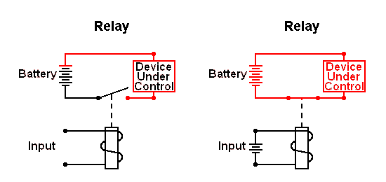

When the coil is energized with direct current, a diode is often placed across the coil to dissipate the energy from the collapsing magnetic field at deactivation, which would otherwise generate a voltage spike dangerous to semiconductor circuit components. Such diodes were not widely used before the application of transistors as relay drivers, but soon became ubiquitous as early germanium transistors were easily destroyed by this surge. Some automotive relays include a diode inside the relay case.

If the relay is driving a large, or especially a reactive load, there may be a similar problem of surge currents around the relay output contacts. In this case a snubber circuit (a capacitor and resistor in series) across the contacts may absorb the surge. Suitably rated capacitors and the associated resistor are sold as a single packaged component for this commonplace use.

If the coil is designed to be energized with alternating current (AC), some method is used to split the flux into two out-of-phase components which add together, increasing the minimum pull on the armature during the AC cycle. Typically this is done with a small copper "shading ring" crimped around a portion of the core that creates the delayed, out-of-phase component, which holds the contacts during the zero crossings of the control voltage.[10]

Contact materials for relays vary by application. Materials with low contact resistance may be oxidized by the air, or may tend to "stick" instead of cleanly parting when opening. Contact material may be optimized for low electrical resistance, high strength to withstand repeated operations, or high capacity to withstand the heat of an arc. Where very low resistance is required, or low thermally-induced voltages are desired, gold-plated contacts may be used, along with palladium and other non-oxidizing, semi-precious metals. Silver or silver-plated contacts are used for signal switching. Mercury-wetted relays make and break circuits using a thin, self-renewing film of liquid mercury. For higher-power relays switching many amperes, such as motor circuit contactors, contacts are made with a mixtures of silver and cadmium oxide, providing low contact resistance and high resistance to the heat of arcing. Contacts used in circuits carrying scores or hundreds of amperes may include additional structures for heat dissipation and management of the arc produced when interrupting the circuit. Some relays have field-replaceable contacts, such as certain machine tool relays; these may be replaced when worn out, or changed between normally open and normally closed state, to allow for changes in the controlled circuit.

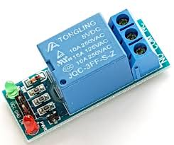

3.3 CURRENT SENSOR

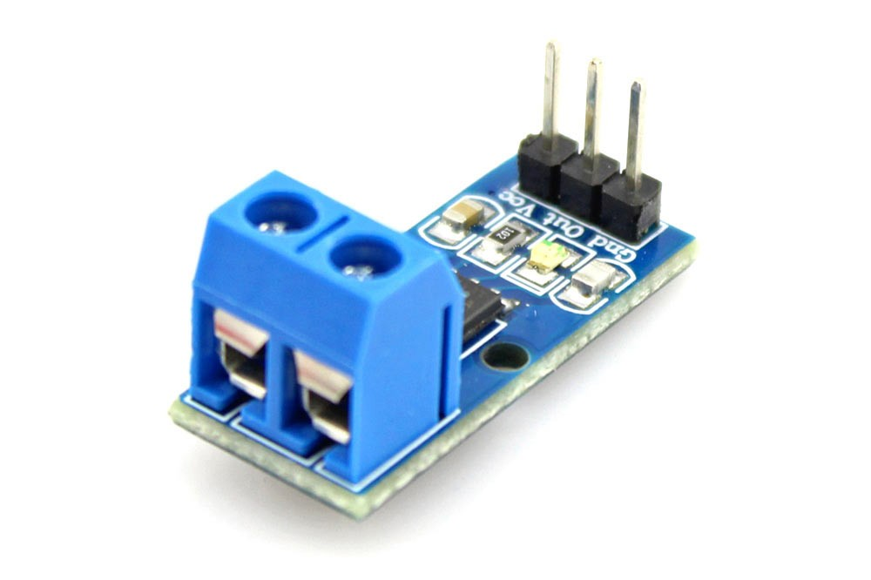

Sensing and controlling current flow is a fundamental requirement in a wide variety of applications including, over-current protection circuits, battery chargers, switching mode power supplies, digital watt meters, programmable current sources, etc. This ACS721 current module is based on ACS712 sensor, which can accurately detect AC or DC current. The maximum AC or DC that can be detected can reach 30A, and the present current signal can be read via analog I / O port of Arduino.

**Specification**

* Supply Voltage: 4.5V~5.5V DC
* Measure Current Range: -30A~ 30A
* Sensitivity: 66mV/A

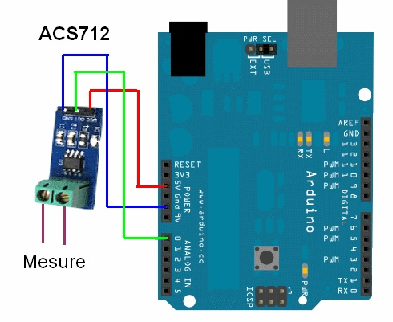

A **current sensor** is a device that detects electric current in a wire, and generates a signal proportional to that current. The generated signal could be analog voltage or current or even a digital output. The generated signal can be then used to display the measured current in an ammeter, or can be stored for further analysis in a data acquisition system, or can be used for the purpose of control.

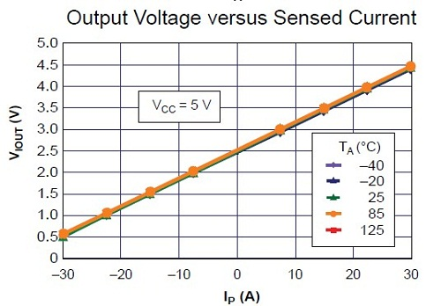

The sensed current and the output signal can be:

* Alternating current input,
* Analog output, which duplicates the wave shape of the sensed current.
* Bipolar output, which duplicates the wave shape of the sensed current.
* Unipolar output, which is proportional to the average or RMS value of the sensed current.
* Direct current input,
* Unipolar, with a unipolar output, which duplicates the wave shape of the sensed current
* Digital output, which switches when the sensed current exceeds a certain threshold technologies.
* Hall effect IC sensor.
* Transformer or current clamp meter, (suitable for AC current only).
* Fluxgate Transformer Type, (suitable for AC or DC current).
* Resistor, whose voltage is directly proportional to the current through it.
* Fiber optic current sensor, using an interferometer to measure the phase change in the light produced by a magnetic field.
* Rogowski coil, electrical device for measuring alternating current (AC) or high speed current pulses.

The Hall Effect current sensor is a type of current sensor which is based on the Hall Effect phenomenon discovered by Edwin Hall in 1879.

Hall Effect current sensors can measure all types of current signals (i.e. AC, DC, or pulsating current).

These sensors are currently being used widely in many industries because of their vast applications and the type of output they provide, which can be manipulated and can be used for various application.

3.4 LCD 16x2

LCD (Liquid Crystal Display) screen is an electronic display module and find a wide range of applications. A 16x2 LCD display is very basic module and is very commonly used in various devices and circuits. These modules are preferred over seven segments and other multi segment LEDs. The reasons being: LCDs are economical; easily programmable; have no limitation of displaying special & even custom characters (unlike in seven segments), animations and so on.

A **16x2 LCD** means it can display 16 characters per line and there are 2 such lines. In this LCD each character is displayed in 5x7 pixel matrix. This LCD has two registers, namely, Command and Data.

The command register stores the command instructions given to the LCD. A command is an instruction given to LCD to do a predefined task like initializing it, clearing its screen, setting the cursor position, controlling display etc. The data register stores the data to be displayed on the LCD. The data is the ASCII value of the character to be displayed on the LCD. Click to learn more about internal structure of a LCD.

**Pin Diagram:**

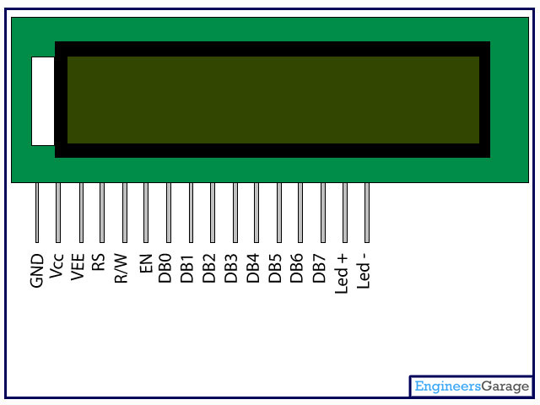

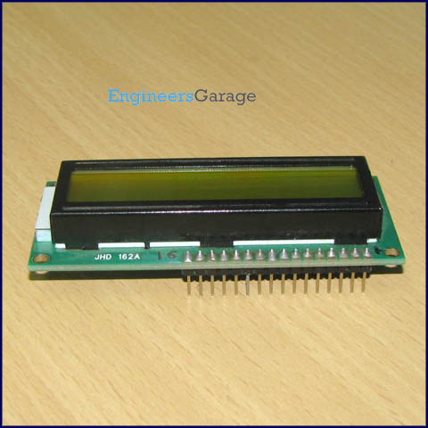

**Pin Description:**

|  |  |  |
| --- | --- | --- |
| **Pin No** | **Function** | **Name** |
| 1 | Ground (0V) | Ground |
| 2 | Supply voltage; 5V (4.7V – 5.3V) | Vcc |
| 3 | Contrast adjustment; through a variable resistor | VEE |
| 4 | Selects command register when low; and data register when high | Register Select |
| 5 | Low to write to the register; High to read from the register | Read/write |
| 6 | Sends data to data pins when a high to low pulse is given | Enable |
| 7 | 8-bit data pins | DB0 |
| 8 | DB1 |
| 9 | DB2 |
| 10 | DB3 |
| 11 | DB4 |
| 12 | DB5 |
| 13 | DB6 |
| 14 | DB7 |
| 15 | Backlight VCC (5V) | Led+ |
| 16 | Backlight Ground (0V) | Led- |

3.5 ARDUINO AT mega 328 Microcontroller

**Defining Arduino**

An Arduino is actually a microcontroller based kit which can be either used directly by purchasing from the vendor or can be made at home using the components, owing to its open source hardware feature. It is basically used in communications and in controlling or operating many devices. It was founded by Massimo Banzi and David Cuartielles in 2005.

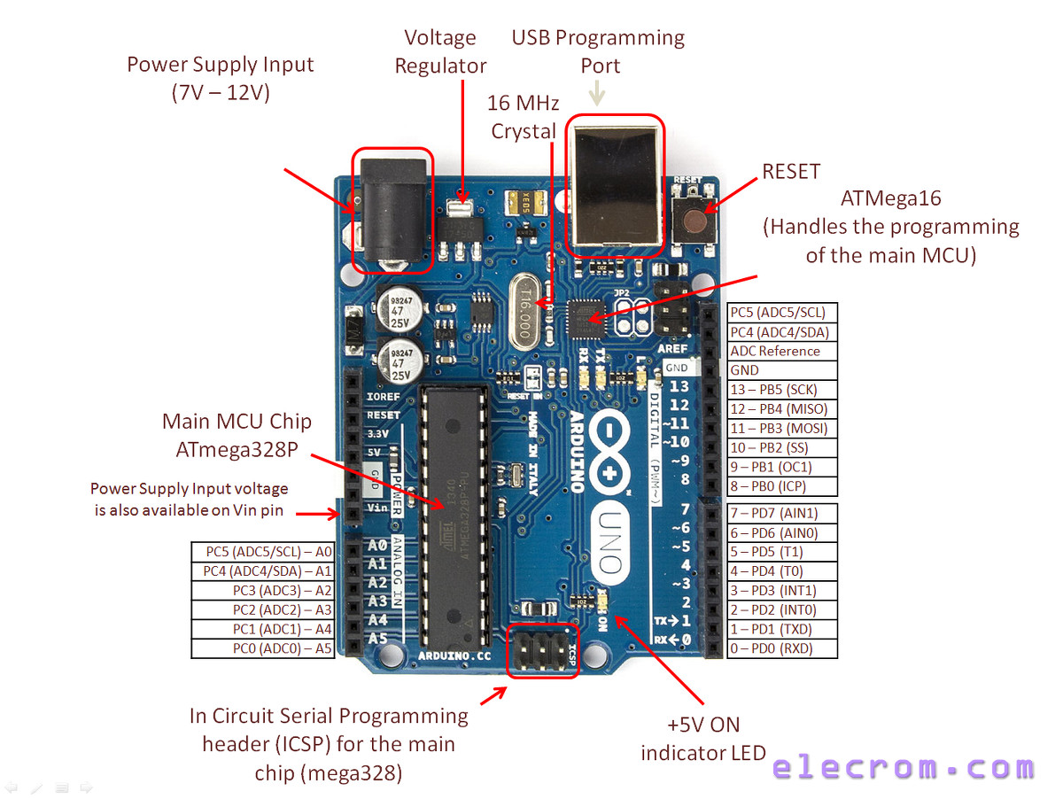

**Arduino Architecture:**

Arduino’s processor basically uses the Harvard architecture where the program code and program data have separate memory. It consists of two memories- Program memory and the data memory.The code is stored in the flash program memory, whereas the data is stored in the data memory. The Atmega328 has 32 KB of flash memory for storing code (of which 0.5 KB is used for the bootloader), 2 KB of SRAM and 1 KB of EEPROM and operates with a clock speed of 16MHz.

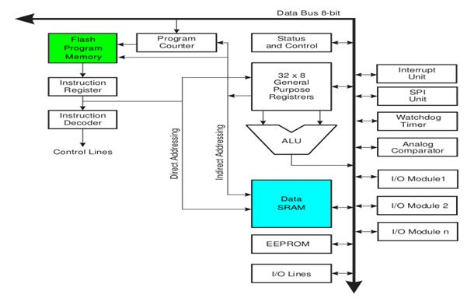Arduino Architecture

**Arduino Pin Diagram**

A typical example of Arduino board is Arduino Uno. It consists of ATmega328- a 28 pin microcontroller.

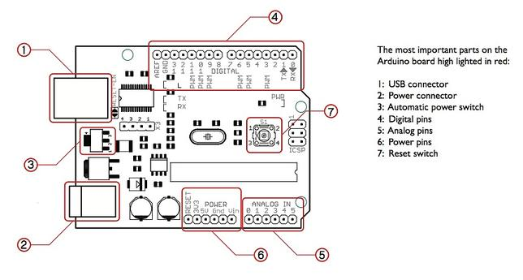Arduino Pin Diagram

Arduino Uno consists of 14 digital input/output pins (of which 6 can be used as PWM outputs), 6 analog inputs, a 16 MHz crystal oscillator, a USB connection, a power jack, an ICSP header, and a reset button

**Power Jack**:  Arduino can be power either from the pc through a USB or through external source like adaptor or a battery. It can operate on a external supply of 7 to 12V. Power can be applied externally through the pin Vin or by giving voltage reference through the IORef pin.

**Digital Inputs**: It consists of 14 digital inputs/output pins, each of which provide or take up 40mA current. Some of them have special functions like pins 0 and 1, which act as Rx and Tx respectively , for serial communication, pins 2 and 3-which are external interrupts, pins 3,5,6,9,11 which provides pwm output and pin 13 where LED is connected.

**Analog inputs**: It has 6 analog input/output pins, each providing a resolution of 10 bits.

**ARef**: It provides reference to the analog inputs

**Reset**: It resets the microcontroller when low.

**How to program an Arduino?**

The most important advantage with Arduino is the programs can be directly loaded to the device without requiring any hardware programmer to burn the program. This is done because of the presence of the 0.5KB of Bootloader which allows the program to be burned into the circuit. All we have to do is to download the Arduino software and writing the code.

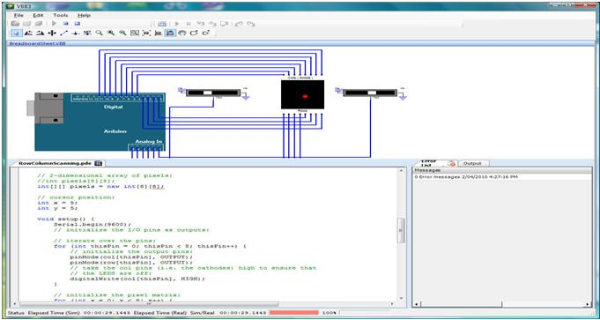

The Arduino tool window consists of the toolbar with the buttons like verify, upload, new, open, save, serial monitor. It also consists of a text editor to write the code, a message area which displays the feedback like showing the errors, the text console which displays the output and a series of menus like the File, Edit, Tools menu.

**5 Steps to program an Arduino**

* Programs written in Arduino are known as sketches. A basic sketch consists of 3 parts

1. Declaration of Variables  
2. Initialization: It is written in the setup () function.  
3. Control code: It is written in the loop () function.

* The sketch is saved with .ino extension. Any operations like verifying, opening a sketch, saving a sketch can be done using the buttons on the toolbar or using the tool menu.
* The sketch should be stored in the sketchbook directory.
* Chose the proper board from the tools menu and the serial port numbers.
* Click on the upload button or chose upload from the tools menu. Thus the code is uploaded by the boot loader onto the microcontroller.

**Few of basic Arduino functions are:**

* **digitalRead**(pin): Reads the digital value at the given pin.
* **digitalWrite**(pin, value): Writes the digital value to the given pin.
* **pinMode**(pin, mode): Sets the pin to input or output mode.
* **analogRead**(pin): Reads and returns the value.
* **analogWrite**(pin, value): Writes the value to that pin.
* **serial.begin**(baud rate): Sets the beginning of serial communication by setting the bit rate.

**How to Design your own Arduino?**

We can also design our own Arduino by following the schematic given by the Arduino vendor and also available at the websites. All we need are the following components- A breadboard, a led, a power jack, a IC socket, a microcontroller, few resistors, 2 regulators, 2 capacitors.

* The IC socket and the power jack are mounted on the board.
* Add the 5v and 3.3v regulator circuits using the combinations of regulators and capacitors.
* Add proper power connections to the microcontroller pins.
* Connect the reset pin of the IC socket to a 10K resistor.
* Connect the crystal oscillators to pins 9 and 10
* Connect the led to the appropriate pin.
* Mount the female headers onto the board and connect them to the respective pins on the chip.
* Mount the row of 6 male headers, which can be used as an alternative to upload programs.
* Upload the program on the Microcontroller of the readymade Adruino and then pry it off and place back on the user kit.

**7 Reasons why Arduino is being preferred these days**

1. It is inexpensive
2. It comes with an open source hardware feature which enables users to develop their own kit using already available one as a reference source.
3. The Arduino software is compatible with all types of operating systems like Windows, Linux, and Macintosh etc.
4. It also comes with open source software feature which enables experienced software developers to use the Arduino code to merge with the existing programming language libraries and can be extended and modified.
5. It is easy to use for beginners.
6. We can develop an Arduino based project which can be completely stand alone or projects which involve direct communication with the software loaded in the computer.
7. It comes with an easy provision of connecting with the CPU of the computer using serial communication over USB as it contains built in power and reset circuitry.

So this is some basic idea regarding an Arduino. You can use it for many types of applications. For instance in applications involving controlling some actuators like motors, generators, based on the input from sensors.

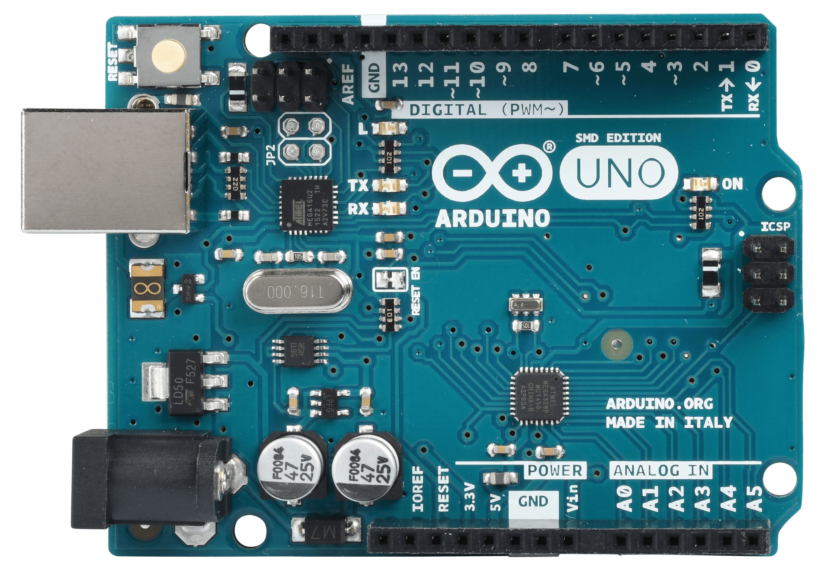

**From Arduino to a Microcontroller on a Breadboard**

This tutorial explains how to migrate from an Arduino board to a standalone microcontroller on a breadboard. It's similar to this tutorial, but uses an Arduino board to program the AT mega on the breadboard.

Unless you choose to use the minimal configuration described at the end of this tutorial, you'll need four components (besides the Arduino, ATmega328, and breadboard):

* a 16 MHz crystal,
* a 10k resistor, and
* two 18 to 22 picofarad (ceramic) capacitors.

|  |
| --- |
| **Burning the Boot loader**  If you have a new ATmega328 (or ATmega168), you'll need to burn the boot loader onto it. You can do this using an Arduino board as an in-system program (ISP). If the microcontroller already has the boot loader on it (e.g. because you took it out of an Arduino board or ordered an already-boot loaded AT mega), you can skip this section.  To burn the boot loader, follow these steps:   1. Upload the Arduino ISP sketch onto your Arduino board. (You'll need to select the board and serial port from the Tools menu that correspond to your board.) 2. Wire up the Arduino board and microcontroller as shown in the diagram to the right. 3. Select "Arduino Duemilanove or Nano w/ ATmega328" from the Tools > Board menu. (Or "ATmega328 on a breadboard (8 MHz internal clock)" if using the minimal configuration described below.) 4. Select "Arduino as ISP" from Tools > Programmer 5. Run Tools > Burn Boot loader   You should only need to burn the boot loader once. After you've done so, you can remove the jumper wires connected to pins 10, 11, 12, and 13 of the Arduino board. |

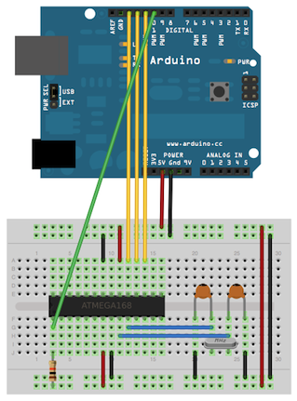

*Using an Arduino board to burn the boot loader onto an AT mega on a breadboard.*

**Uploading Using an Arduino Board**

Once your ATmega328p has the Arduino boot loader on it, you can upload programs to it using the USB-to-serial convertor (FTDI chip) on an Arduino board. To do, you remove the microcontroller from the Arduino board so the FTDI chip can talk to the microcontroller on the breadboard instead. The diagram at right shows how to connect the RX and TX lines from the Arduino board to the AT mega on the breadboard. To program the microcontroller, select "Arduino Duemilanove or Nano w/ ATmega328" from the Tools > Board menu (or "ATmega328 on a breadboard (8 MHz internal clock)" if you're using the minimal configuration described below). Then upload as usual.

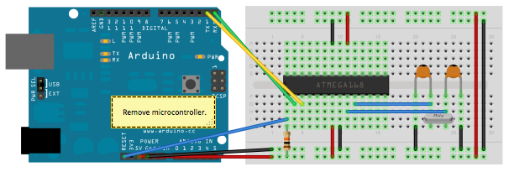

*Uploading sketches to an AT mega on a breadboard. Remember to remove the microcontroller from the Arduino board!*

**Minimal Circuit (Eliminating the External Clock**)

If you don't have the extra 16 MHz crystal and 18-22 picofarad capacitors used in the above examples, you can configure the ATmega328 to use its internal 8 MHz RC oscillator as a clock source instead. (You don't really need the 10K pull-up resistor on the reset pin either, so we remove it to get a truly minimal configuration.)

You'll need to install support for an additional hardware configuration:

1. Download this hardware configuration archive: breadboard-1-6-x.zip, Breadboard1-5-x.zip or Breadboard1-0-x.zipdepending on which IDE you use.
2. Create a "hardware" sub-folder in your Arduino sketchbook folder (whose location you can find in the Arduino preferences dialog). If you've previously installed support for additional hardware configuration, you may already have a "hardware" folder in your sketchbook.
3. Move the breadboard folder from the zip archive to the "hardware" folder of your Arduino sketchbook.
4. Restart the Arduino software.
5. You should see "ATmega328 on a breadboard (8 MHz internal clock)" in the Tools > Board menu.

Once you've done this, you can burn the boot loader and upload programs onto your ATmega328 as described above. Be sure to select "ATmega328 on a breadboard (8 MHz internal clock)" when burning the boot loader. (If you select the wrong item and configure the microcontroller to use an external clock, it won't work unless you connect one.)

|  |  |
| --- | --- |
| *Using an Arduino board to burn the boot loader onto an AT mega on a breadboard (w/o an external clock).* | *Uploading sketches to an AT mega on a breadboard.* |

**3.6 GSM MODULE**

GSM is a mobile communication modem; it is stands for global system for mobile communication (GSM). The idea of GSM was developed at Bell Laboratories in 1970.  It is widely used mobile communication system in the world. GSM is an open and digital cellular technology used for transmitting mobile voice and data services operates at the 850MHz, 900MHz, 1800MHz and 1900MHz frequency bands.

GSM system was developed as a digital system using time division multiple access (TDMA) technique for communication purpose. A GSM digitizes and reduces the data, then sends it down through a channel with two different streams of client data, each in its own particular time slot. The digital system has an ability to carry 64 kbps to 120 Mbps of data rates.

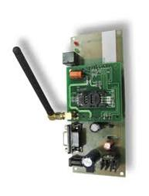

GSM Modem

There are various cell sizes in a GSM system such as macro, micro, pico and umbrella cells. Each cell varies as per the implementation domain. There are five different cell sizes in a GSM network macro, micro, pico and umbrella cells. The coverage area of each cell varies according to the implementation environment.

Time Division Multiple Access

TDMA technique relies on assigning different time slots to each user on the same frequency. It can easily adapt to data transmission and voice communication and can carry 64kbps to 120Mbps of data rate.

GSM Architecture

A GSM network consists of the following components:

* A Mobile Station:  It is the mobile phone which consists of the transceiver, the display and the processor and is controlled by a SIM card operating over the network.
* Base Station Subsystem: It acts as an interface between the mobile station and the network subsystem. It consists of the Base Transceiver Station which contains the radio transceivers and handles the protocols for communication with mobiles. It also consists of the Base Station Controller which controls the Base Transceiver station and acts as a interface between the mobile station and mobile switching centre.
* Network Subsystem: It provides the basic network connection to the mobile stations. The basic part of the Network Subsystem is the Mobile Service Switching Centre which provides access to different networks like ISDN, PSTN etc. It also consists of the Home Location Register and the Visitor Location Register which provides the call routing and roaming capabilities of GSM. It also contains the Equipment Identity Register which maintains an account of all the mobile equipments wherein each mobile is identified by its own IMEI number. IMEI stands for International Mobile Equipment Identity.

Features of GSM Module:

* Improved spectrum efficiency
* International roaming
* Compatibility with integrated services digital network (ISDN)
* Support for new services.
* SIM phonebook management
* Fixed dialing number (FDN)
* Real time clock with alarm management
* High-quality speech
* Uses encryption to make phone calls more secure
* Short message service (SMS)

The security strategies standardized for the GSM system make it the most secure telecommunications standard currently accessible. Although the confidentiality of a call and secrecy of the GSM subscriber is just ensured on the radio channel, this is a major step in achieving end-to- end security.

GSM Modem

A GSM modem is a device which can be either a mobile phone or a modem device which can be used to make a computer or any other processor communicate over a network. A GSM modem requires a SIM card to be operated and operates over a network range subscribed by the network operator.  It can be connected to a computer through serial, USB or Bluetooth connection.

A GSM modem can also be a standard GSM mobile phone with the appropriate cable and software driver to connect to a serial port or USB port on your computer. GSM modem is usually preferable to a GSM mobile phone. The GSM modem has wide range of applications in transaction terminals, supply chain management, security applications, weather stations and GPRS mode remote data logging.

Working of GSM Module:

From the below circuit, a GSM modem duly interfaced to the MC through the level shifter IC Max232. The SIM card mounted GSM modem upon receiving digit command by SMS from any cell phone send that data to the MC through serial communication. While the program is executed, the GSM modem receives command ‘STOP’ to develop an output at the MC, the contact point of which are used to disable the ignition switch. The command so sent by the user is based on an intimation received by him through the GSM modem ‘ALERT’ a programmed message only if the input is driven low. The complete operation is displayed over 16×2 LCD display.

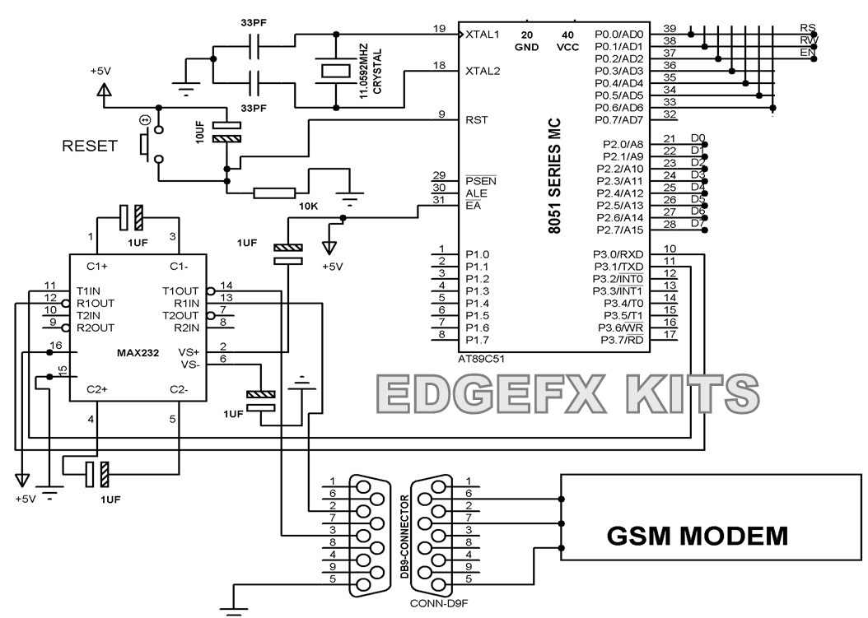

GMS Modem Circuit

Intelligent GSM Device for Automation and Security

In these days, the GSM mobile terminal has become one of the items that are constantly with us. Just like our wallet/purse, keys or watch, the GSM mobile terminal provides us a communication channel that enables us to communicate with the world. The requirement for a person to be reachable or to call anyone at any time is very appealing.

In this project, as the name says project is based on GSM network technology for transmission of SMS from sender to receiver. SMS sending and receiving is used for ubiquitous access of appliances and allowing breach control at home. The system proposes two sub-systems. Appliance control subsystem enables the user to control home appliances remotely and the security alert subsystem gives the automatic security monitoring.

The system is capable enough to instruct user via SMS from a specific cell number to change the condition of the home appliance according to the user’s needs and requirements. The second aspect is that of security alert which is achieved in a way that on the detection of intrusion, the system allows automatic generation of SMS thus alerting the user against security risk.

**GSM module interfacing with Arduino: Send and receive SMS**

**Interfacing GSM SIM900A with Arduino:**SIM900A is an ultra-compact and reliable wireless module. The SIM900A is a complete Dual-band GSM/GPRS solution in a SMT module which can be embedded in the customer applications. Featuring an industry-standard interface, the SIM900A delivers GSM/GPRS 900/1800MHz performance for voice, SMS, Data, and Fax in a small form factor and with low power consumption. With a tiny configuration of 24mmx24mmx3mm, SIM900A can fit in almost all the space requirements in user applications, especially for slim and compact demand of design.

**Features:**

* Dual-Band 900/ 1800 MHz
* GPRS multi-slot class 10/8GPRS mobile station class B
* Compliant to GSM phase 2/2+Class 4 (2 W @850/ 900 MHz)
* Class 1 (1 W @ 1800/1900MHz)
* Control via AT commands (GSM 07.07 ,07.05 and SIMCOM enhanced AT Commands)
* Low power consumption: 1.5mA(sleep mode)’
* Operation temperature: -40°C to +85 °C
* Status indicator (D5): It will flash continuously whenever the call arrives otherwise it is left ON.
* Network LED (D6): This led will blink every second which indicates that the GSM module is not connected to the mobile network. Once the connection is established successfully, the LED will blink continuously every 3 seconds.

**Booting the GSM Module:**

1. Insert the SIM card to GSM module and lock it.
2. Connect the adapter to GSM module and turn it ON!
3. Now wait for some time (say 1 minute) and see the blinking rate of ‘status LED’  or ‘network LED’ (GSM module will take some time to establish connection with mobile network)
4. Once the connection is established successfully, the status/network LED will blink continuously every 3 seconds. You may try making a call to the mobile number of the sim card inside GSM module. If you hear a ring back, the gsm module has successfully established network connection.

Okay! Now let’s see how to connect a gsm module to Arduino!

**Connecting GSM module with Arduino**

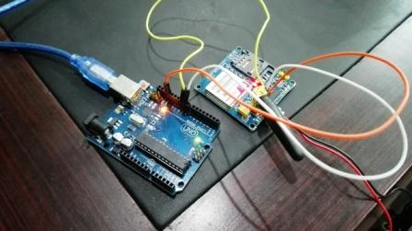

There are two ways of connecting GSM module to Arduino. In any case, the communication between Arduino and GSM module is serial. So we are supposed to use serial pins of Arduino (Rx and Tx). So if you are going with this method, you may connect the Tx pin of GSM module to Rx pin of Arduino and Rx pin of GSM module to Tx pin of Arduino. You read it right? GSM Tx –> Arduino Rx and GSM Rx –> Arduino Tx. Now connect the ground pin of Arduino to ground pin of gsm module! So that’s all! You made 3 connections and the wiring is over! Now you can load different programs to communicate with gsm module and make it work.

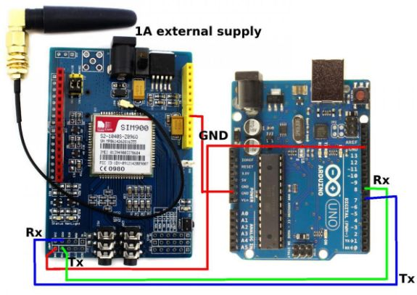

Note:- The problem with this connection is that, while programming Arduino uses serial ports to load program from the Arduino IDE. If these pins are used in wiring, the program will not be loaded successfully to Arduino. So you have to disconnect wiring in Rx and Tx each time you burn the program to Arduino. Once the program is loaded successfully, you can reconnect these pins and have the system working!

To avoid this difficulty, I am using an alternate method in which two digital pins of Arduino are used for serial communication. We need to select two PWM enabled pins of Arduino for this method. So I choose pins 9 and 10 (which are PWM enabled pins). This method is made possible with the SoftwareSerial Library of Arduino. Software Serial is a library of Arduino which enables serial data communication through other digital pins of Arduino. The library replicates hardware functions and handles the task of serial communication.

**CHAPTER 4: WORKING AND ANAYLYSIS**

**4.1 Working and Analysis**

Smart metering using E-Wallet is based on IoT and will be a greatly successful in future when it will be implemented everywhere.

Thus the project consists of various modules which make the whole project run.

The modules included in the Project are as follow:

1. Transformer 230V-AC
2. Current Sensor 30A
3. Relay
4. LCD 16x2
5. Arduino ATmega328
6. GSM Module
7. Arduino IDE
8. C # Programming

Thus, at start we connect the power cable to supply the power to our Arduino Board and other modules. Afterwards it will show the greeting as “SMART METERING USING E-WALLET” on the LCD 16x2 display. Then the Arduino Board which is the ATmega328 version will be running the code and executing it after we upload the ‘Wattmeter.ino’ file using Arduino IDE into the Arduino Board.

The Arduino Board then will execute the code and the program will run where it will calculate the amount of Power consumed by the Electric Bulb.

The current sensor in its part will record and transmit the information about how much Current in Amp is consumed by the Electric Bulb of 100W. Then Current Sensor will send that information to the Arduino Board.

The Arduino Board’s Program has the function of calculating the Power consumed by the Electric bulb. Which is P=V*I where P is Power/Energy consumed in Watts, V is Voltage in volts, and I is Current in Amperes. Then it will calculate the amount of total Power consumed of a minute and will display on the LCD 16x2 display.

The other part of calculation in program code of the Arduino board is that we programmed it such that it will calculate the bill of 1 month in 1 minute for quick demos.

This makes it easier to work quickly and efficiently. The system also then calculates how much balance is remaining. The program itself has a fix amount of money stored to be used in the Meter/Arduino Board. The cash we initialized is 200 Rs. This cash is cut from the wallet of the Smart Meter at the time of Calculating bill and displaying it on the LCD 16x2.

The next step is that the Arduino Board deducts the amount of bill from the Balance in the Wallet. It will then send an SMS using the GSM module to two users as follow:

1. MSEB Number
2. Owner Number

Thus both the Number’s owner will get acknowledge about the amount of bill is deducted and the amount remaining in their Balance. At the same time the Bill generated consists of amount of Bill and also the remaining amount.

If the project is kept running then the Smart Meter will check if there is Balance remaining to deduct or not. If there is not enough balance in the wallet then the Electricity will be cut off from the Bulb and thus it will again generate and SMS regarding that the Consumer needs to recharge that wallet balance in order to keep the Electricity meter running in Future.

The Relay is used to cut off the Power supply to the Electricity Bulb.

The Project is thus made to increase the speed of the billing process in day to day life.

**4.2 CALCULATIONS**

|  |  |  |
| --- | --- | --- |
| **Usual Calculation Period** | **Our Implemented Period for Demo** | **Calculation** |
| 1 Month | 1 Minute | 1 Month calculated units |

**4.2.1 Bill Calculation Period**

**Power Calculation**

P=V*I,

Where

P is Power/energy consumed in watts,

V is Voltage in volts and

I is Current in amperes.

**4.2.2 Bill Amount Calculation**

1 Unit = 7 Rupees

**CHAPTER 5: IMPLEMENTATION**

**5 IMPLEMENTATION**

**5.1** **EXPERIMENTAL SETUP**

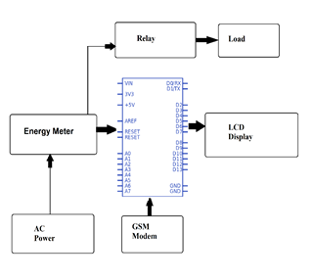

**5.2 PRJEOCT SETUP**

Transformer

GSM module

Power Supply

LED Display

Arduino Board

Current Sensor

Relay

**5.3 FLOWCHART**

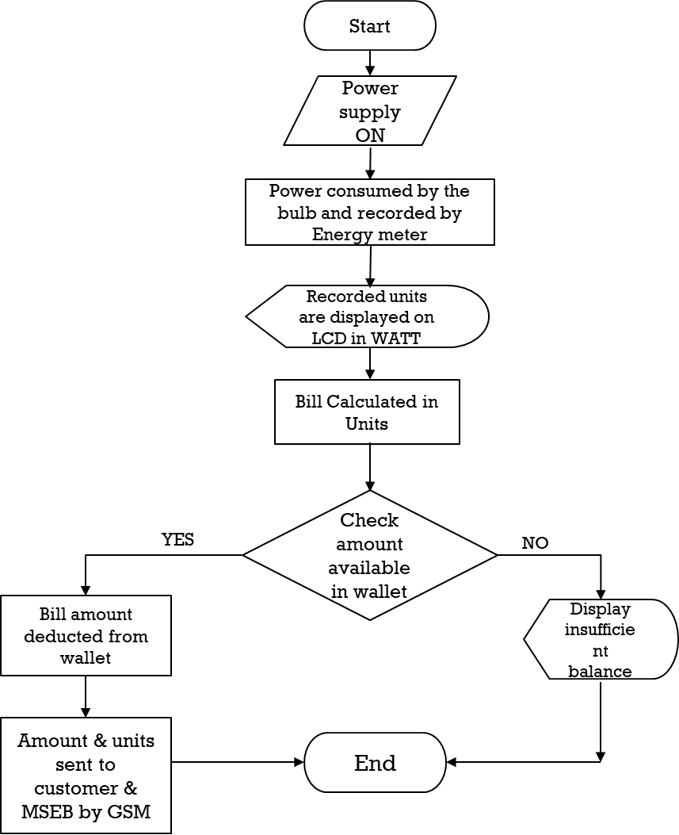

**5.4 ARCHITECTURE**

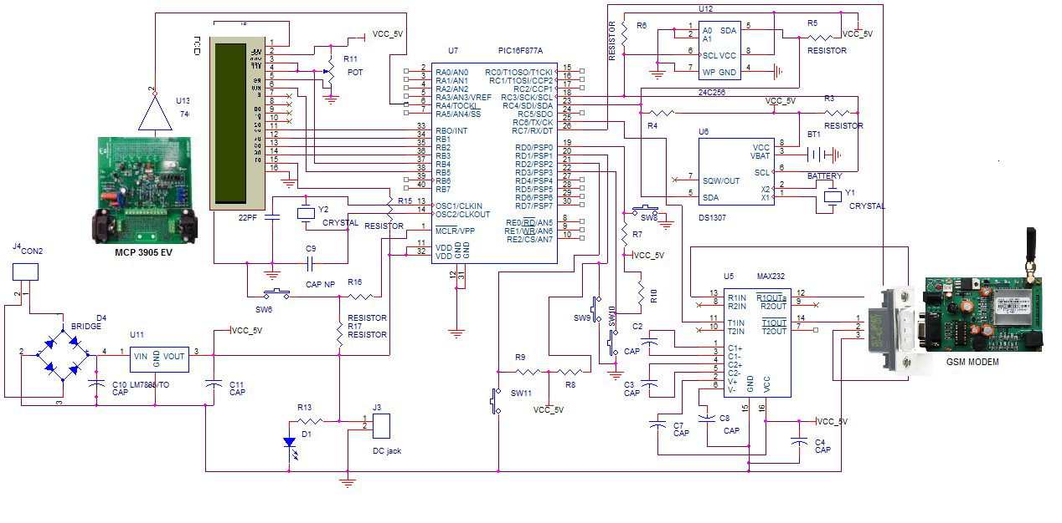

**5.5** **SCREENSHOTS**

**User Side**

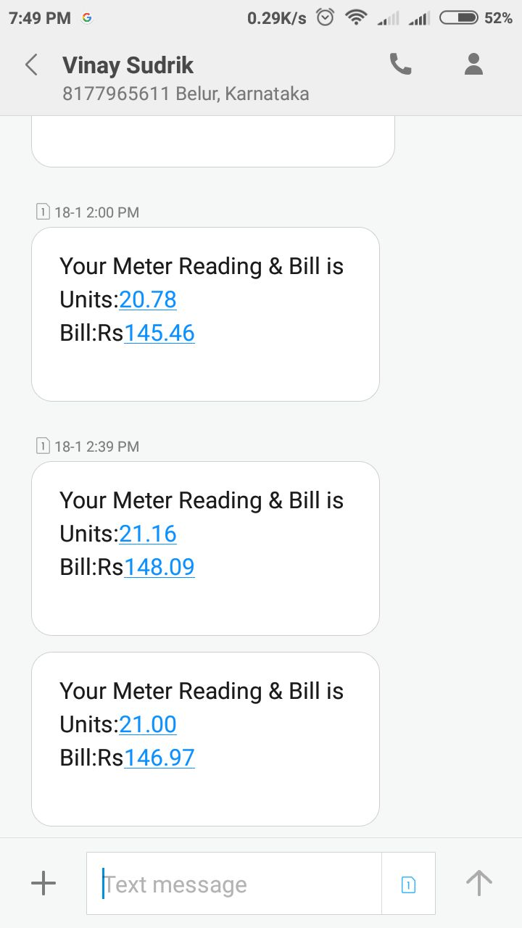

**MSEB Side**

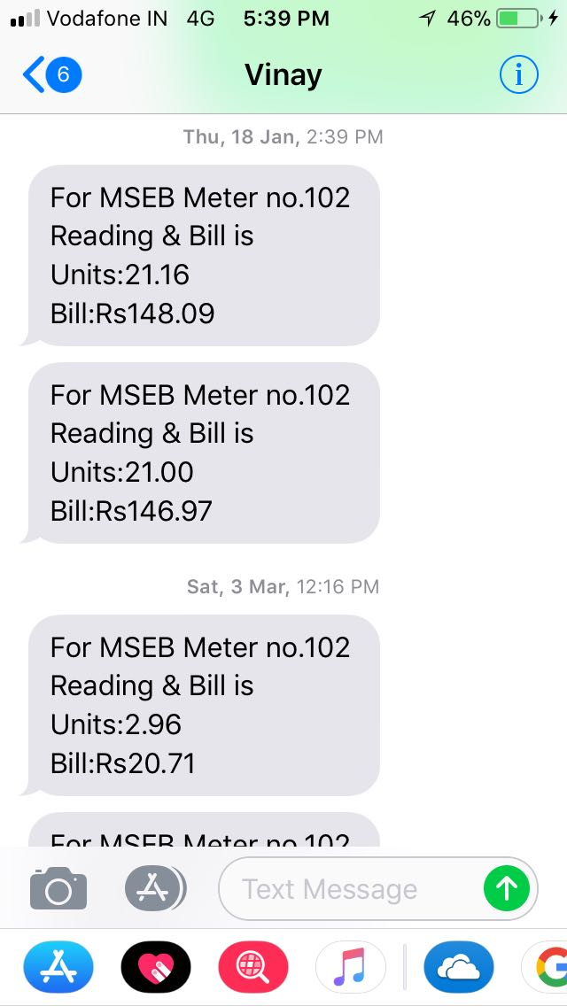

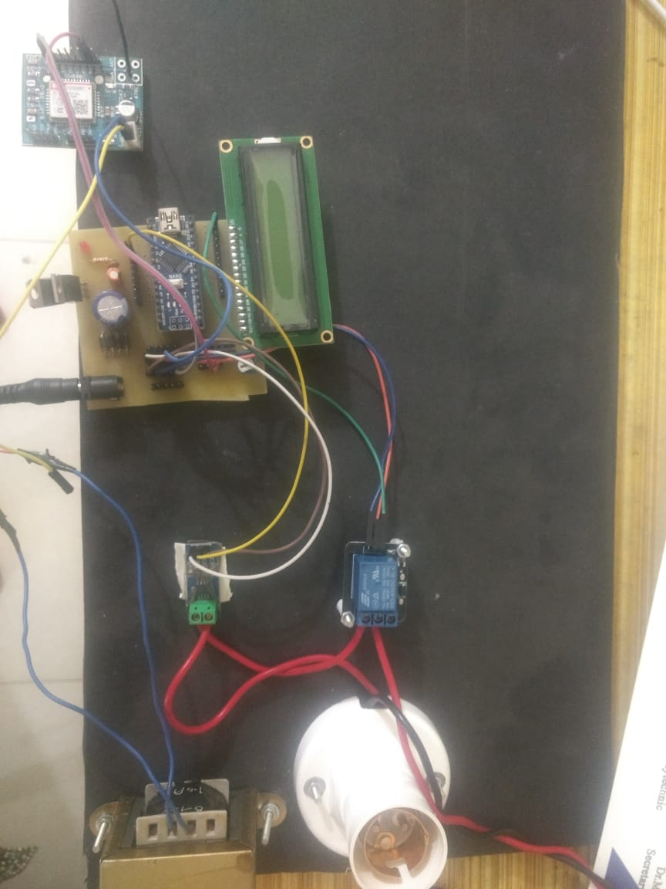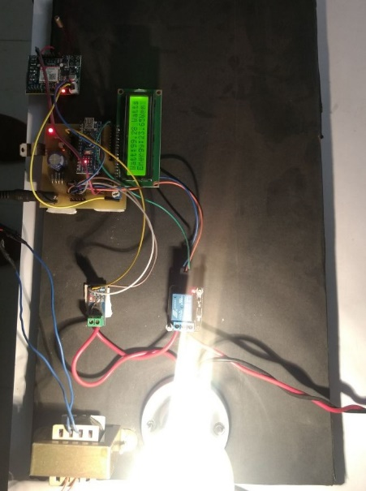**5.6** **TESTING**

**Introduction**

The development of software involves a series of production activities where opportunities of injection of human fallibilities are enormous. Error may begin to occur at the very inception of the process.

Testing is the process of executing the program with the intent of finding an error. A good test case is one that which has high probability of finding an as yet undiscovered error. A successful test is one that uncovers an as yet undiscovered error.

**Testing Strategy**

**White Box Testing**

**White-box testing** (also known as **clear box testing**, **glass box testing**, **transparent box testing**, and **structural testing**) is a method of testing software that tests internal structures or workings of an application, as opposed to its functionality (i.e. black-box testing). In white-box testing an internal perspective of the system, as well as programming skills, are used to design test cases. The tester chooses inputs to exercise paths through the code and determine the expected outputs. This is analogous to testing nodes in a circuit, e.g. in-circuit testing (ICT). White-box testing can be applied at the unit, integration and system levels of the software testing process. Although traditional testers tended to think of white-box testing as being done at the unit level, it is used for integration and system testing more frequently today. It can test paths within a unit, paths between units during integration, and between subsystems during a system–level test. Though this method of test design can uncover many errors or problems, it has the potential to miss unimplemented parts of the specification or missing requirements.

White-box test design techniques include the following code coverage criteria:

* Control flow testing
* Data flow testing
* Branch testing
* Statement coverage
* Decision coverage
* Modified condition/decision coverage
* Prime path testing
* Path testing

**Black Box Testing**

Black-box testing is a method of software testing that examines the functionality of an application without peering into its internal structures or workings. This method of test can be applied virtually to every level of software testing: unit, integration, system and acceptance. It is sometimes referred to as specification-based testing.

Specific knowledge of the application's code/internal structure and programming knowledge in general is not required. The tester is aware of what the software is supposed to do but is not aware of how it does it. For instance, the tester is aware that a particular input returns a certain, invariable output but is not aware of how the software produces the output in the first place.

**Test cases**

Test cases are built around specifications and requirements, i.e., what the application is supposed to do. Test cases are generally derived from external descriptions of the software, including specifications, requirements and design parameters. Although the tests used are primarily functional in nature, non-functional tests may also be used. The test designer selects both valid and invalid inputs and determines the correct output, often with the help of a test oracle or a previous result that is known to be good, without any knowledge of the test object's internal structure.

Test design techniques

Typical black-box test design techniques include:

* Decision table testing
* All-pairs testing
* Equivalence partitioning
* Boundary value analysis
* Cause–effect graph
* Error guessing
* State transition testing
* Use case testing
* User story testing
* Domain analysis
* Syntax testing
* Combining technique

**Testing Types**

**Unit Testing**

Unit testing focuses verification effort on the smallest unit of software design-the software component or module. Using the component-level design description as a guide, important control path are tested to uncover errors within the boundary of module. The relative complexity of test and uncovered errors is limited by the constrained scope established for unit testing. The unit testing is white-box oriented, and the step can be conducted in parallel for multiple components.

Unit testing is normally considered as an adjunct to the coding step. After source level code has been developed, reviewed, and verified for correspondence to component-level design, unit test case design begins. Each test case should be coupled with a set o expected results.

**Integration Testing**

Integration testing exercises several units that have been combined to form a module, subsystem or system. Integration testing focuses on the interfaces between units, to make sure the unit together. The nature of this phase is certainly ‘white box’, as we must have certain knowledge of the units to recognize if we have been successfully in fusing then together in the module.

**Performance testing**

In software engineering, performance testing is testing that is performed to determine how fast some aspect of a system performs under a particular workload. This phase includes testing of the entire application as whole in order to ensure that the application function successfully as a coherent unit without errors and breakup points.

**Test Plans**

Test planning was planned as soon as the requirement specifications were prepared. Detail definition of test cases was started as soon as the design of components was finished.

The first test plan executed generally focuses on individual components, and then the focus shifts towards the larger components. Module testing will be used for each unit. An overall system test will be executed after integration.

**Test Cases for Working**

|  |  |  |  |  |  |  |  |
| --- | --- | --- | --- | --- | --- | --- | --- |
| Test  Scenario | Test  Case | Pre  Condition | Test  Step | Test  Data | Expected  Result | Actual  Results | Pass  /Fail |
| Check the power supply | Check the power supply is given or not | Light switch should be  ON | 1.Plug the pin  2.Put the switch  ON | Power supply | Power must be ON and consume  d by the bulb | Power successfully  consumed | Pass |
| Check  the units are recorded for 1 minute | Check on the LCD whether the units are calculate d or not | Units should be displayed on the display | The  units on the LCD display should be observed | LCD  display | Units should be recorded | Units for 1 minute is recorded | Pass |
| Check whether  the bill is calculat ed and paid | Check  the bill calculatio n and deductio n from wallet | Bill should be calculate d and automatic ally deducted from wallet. Balance of the wallet should be suffcient | 1.The recorded units and bill calculate d is displaye d on  LCD  2.The  bill  amount should be deducted automati cally from the wallet | Units and  bill  amount | Bill  amount should be deducted automati cally | Bill automatica  lly  deducted | Pass |

**CHAPTER 6: CONCLUSION AND FUTURE SCOPE**

**6.1 CONCLUSION**

The complete working model of a smart energy meter was built which uses existing GSM system And E-Wallet facility to recharge your meter. The model will satisfactorily work with home appliances. Automatic meter reading and billing can be explained well using the system. Financial losses of electricity board can be minimized. Labor charges and effort can be reduced. The error, time delay that occurs due to manual metering can be avoided to a great extent. Electrical line fault detection has been made easy for the electricity board. Finally but not the least this type of meter supports remote metering which is the future of energy meters. The smart meters will be part of a much wider IoT in the future integrating multiple aspects of human needs and services to satisfy such needs, and the analytics requirements discussed, such as big data, real time analytics, stream analytics, will need to be built into the processes and workflows for diagnostics in real time.

**6.2 FUTURE SCOPE**

* Adding database for storing all history of payments and all the messages.
* Making an android application for giving an interface to the E-Wallet System.
* Bad environment proofing and preventing destruction will be added.

**6.3 REFERENCES**

K Ashna, Sudhish N George, "GSM Based Automatic Energy Meter Reading System with Instant Billing", *This project was supported and financed by National Institute of Technology Calicut IEEE*, 2013.

The technology of e-metering (Electronic Metering) has gone through rapid technological advancements and there is increased demand for a reliable and efficient. Automatic Meter Reading (AMR) system. This paper presents the design of a simple low cost wireless GSM energy meter and its associated web interface, for automating billing and managing the collected data globally. The proposed system replaces traditional meter reading methods and enables remote access of existing energy meter by the energy provider. Also they can monitor the meter readings regularly without the person visiting each house. A GSM based wireless communication module is integrated with electronic energy meter of each entity to have remote access over the usage of electricity. A PC with a GSM receiver at the other end, which contains the database acts as the billing point. Live meter reading from the GSM enabled energy meter is sent back to this billing point periodically and these details are updated in a central database. A new interactive, user-friendly graphical user interface is developed using Microsoft visual studio .NET framework and C#. With proper authentication, users can access the developed web page details from anywhere in the world. The complete monthly usage and the bill is messaged back to the customer after processing these data.

O. Homa Kesav, B. Abdul Rahim, "Automated Wireless Meter Reading System for Monitoring and Controlling Power Consumption", *International Journal of Recent Technology and Engineering*, vol. 1, no. 2, June 2012.

 This paper describes about the implementation of wireless automatic electric meter (AMR) network, implementing based on ZigBee technology for reduced power consumption. Wireless Electric meter is used for the collection of unit count and it is evolved from traditional meter reading scheme and power theft from the transmission line. This wireless automatic reading technology saves human resources and improves the accuracy. ZigBee is used as communication protocol since the application don’t need high speed data rate, need to be low powered and low cost. Reduced power consumption can be effectively achieved and this system focused to implement in a building or in an office.

**ANNEXURE A**

**Annexure A**

**PUBLISHED PAPER**

**Smart Metering Using E-wallet**

**Mrs. Nilam Jadhav 1, Utkarsh Bhangale2, Vinay Sudrik3, Prafful Wania4, Sumit Bhattacharya5**

*1 Lecturer, Department of Computer Engineering, Pimpri Chinchwad Polytechnic College, Maharashtra, India*

*2,3,4,5 Student, Department of Computer Engineering, Pimpri Chinchwad Polytechnic College, Maharashtra, India*

---------------------------------------------------------------------***---------------------------------------------------------------------

**Abstract -** *In old days, there existed electricity meters but which work on some metallic strip like mechanism thus had a disadvantage of freezing the meter with the use of magnet. To overcome this problem new meters came which is still used since like from 2000. One thing was sure no one was able to* ***freeze*** *the reading meter installed in the current electricity meter. Thus it is a successful prototype.*

*But we still have a problem with this meter, i.e. there is unusual work load on people who come to collect the reading of the electricity meter. Also no new paying system is generated. There is* ***payment*** *done* ***online*** *but after when a person checks the reading at the month end and our bill is generated. To overcome this we made this prototype called as Smart Electricity Meter. In which we added some extra features and also implemented* ***IoT (Internet of Things)****. In our module we installed* ***Arduino board*** *which is like the brain of this meter handles the transaction and messaging functions. The Smart Electricity Meter helps us to reduce unusual workload on workers of the* ***MSEB****. Thus saving time and money. It has a unique system which calculates the money and energy and generates a bill which is then sent through message to MSEB and to the* ***OWNER*** *of the meter.*

**1 Introduction**

With the great developments in the field of Internet and technologies, everything has become digital. Internet has become an important part of our lives. A new technology has entered into this picture known as Internet of Things (IoT). Internet of Things is a network comprises of many electronic devices and sensors which are connected together to exchange some information over the web. The devices based on IoT seem talking and sharing data with each other. Smart Meter is one of the applications of IoT. It records the consumption and sends the readings to the utility office on regular basis for monitoring and billing. For a long time, traditional electromechanical meters have been used. Meter readings were noted down on the monthly basis. But now with the evolution of smart electricity meters, things are changing

In this project we will be using the sensor which is fixed in the meter and the details of the units will be stored in the cloud and from the cloud the message will be send to the MSEB and to the user on the daily basis, and then the user can pay the bill by using the e-payment. By using this system the user can know how much light the particular device consumes in his or her home.

Also we add one more feature in it The Prepaid Energy Meter which allows user to use prepaid energy meter functionality. Using this functionality user will able to pay in advance and use the exact amount of energy.

The system starts with GSM modem Connection and first configures the user number and gives authority to that number. The system is made up of AVR Microcontroller, current sensors, GSM modem, LCD display, energy meter and loads.

**1.1 Objective**

The main objective is to automate the manual process of taking readings, calculating bills and then handing them to the user. All the process from calculating the exact use of electricity to paying the Bills to MSEB is made digital and can be automated. The main objective is to make the work of MSEB easier and hustle free.

**1.2 Literature Survey**

The paper titled Internet of Things based Smart Electricity Meters proposes a system for smart meter. This paper proposes a new smart meter which need to be replaced. Thus all the old meters need to be replaced with this new meter. This is main drawback of the system. Another research paper titled Smart Electricity Meter Data Intelligence for Future Energy Systems: A Survey presented the current smart-metering space as the smart-metering landscape, and then, a framework has been established to relate smart meter data to stakeholders and applications created by their needs and the analytics tools and techniques required to achieve the stakeholder needs.

In the existing system the particular person checks the meter units by manually going there clicking the photo of the meter and then calculating the amount according to the units, then they will send the bill to the user by post/by hand. So this whole process is so much lengthy and consumes a lot of time.

The proposed system not only automates the meter readings but also provide the user with facility of prepaid electricity bill payment. Thus it is more user friendly. Also the existing system need not to be replaced just the additional hardware needs to be installed in existing meters.

**2. Scope of the project**

* The system will be used to provide bill to consumer both as an SMS along with other in-built features such as tamper proof, fault detection.
* The proposed energy meter utilizes a GSM module to transfer energy consumed to the authority side.
* Similarly authority side also uses these GSM service to send back the bill.
* Electricity bill will be automatically deducted from E-Wallet.
* Customers can recharge their meter through E-Wallet Facility.

**2.1 Architectural Model (Project block diagram)**

**2.2 Requirements**

**a. Software Requirements**

* Arduino IDE
* Embedded C Programming Language

**b. Hardware Requirements**

* Arduino Nano AT mega 328 Microcontroller
* Current Sensor
* GSM Modem
* LCD Display
* Energy Meter
* Loads
* Resisters
* Capacitors
* Diodes

**2.3 Advantages of project**

* Saves the time
* Fast processing
* E-Payment Facility
* Can know the light consume by each device in our home

**2.4 Limitations of project**

* Transitioning to new technology and processes
* Managing public reaction and customer acceptance of the new meters
* Making a long-term financial commitment to the new metering technology and related software
* Managing and storing vast quantities of metering data.
* Ensuring the security of metering data.
* Paying additional fees for the new meter

**3. Conclusions**

The complete working model of a smart energy meter was built which uses existing GSM system And E-Wallet facility to recharge your meter. The model will satisfactorily work with home appliances. Automatic meter reading and billing can be explained well using the system. Financial losses of electricity board can be minimized. Labor charges and effort can be reduced. The error, time delay that occurs due to manual metering can be avoided to a great extent. Electrical line fault detection has been made easy for the electricity board. Finally but not the least this type of meter supports remote metering which is the future of energy meters. The smart meters will be part of a much wider IoT in the future integrating multiple aspects of human needs and services to satisfy such needs, and the analytics requirements discussed, such as big data, real time analytics, stream analytics, will need to be built into the processes and workflows for diagnostics in real time.

**Screenshot**



**References**

[1] Sudhish N George and Ashna K, GSM based automatic energy meter reading system with instant billing, IEEE publications for International Multi-Conference on Automation, Computing, Communication, Control and Compressed Sensing(iMac4s), 2013 ,March 2013, pp. 65-71.

[2] Syed Khizar Ali Zaidi, Design and implementation of low cost electronic prepaid energy meter, Proceedings of the 12th IEEE International Multitopic Conference, December 23-24,2008, pp 548-552.

[3] H G Rodney Tan,C H Lee and V H Mok, Automatic power meter reading system using GSM network ,The 8th International Power Engineering Conference (IPEC 2007) , pp. 465-469.

[4] A Geetha and Dr.K Jamuna, Smart metering system International Conference on Information Communication and Embedded Systems (ICICES), 2013, pp 1-5.

[5] Arghya Sarkar and S. Sengupta, A novel instantaneous power factor measurement method based on wavelet transform, IEEE Power India Conference, 2006,pp 1-6.

CERTIFICATES

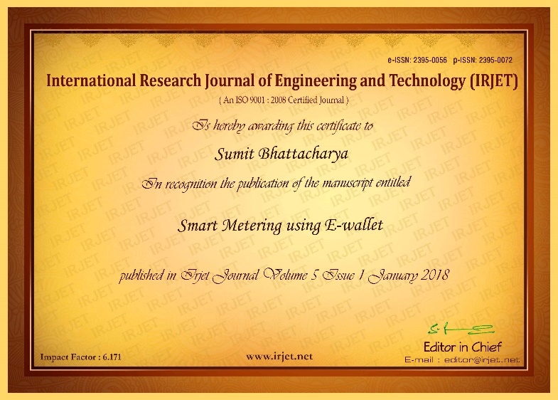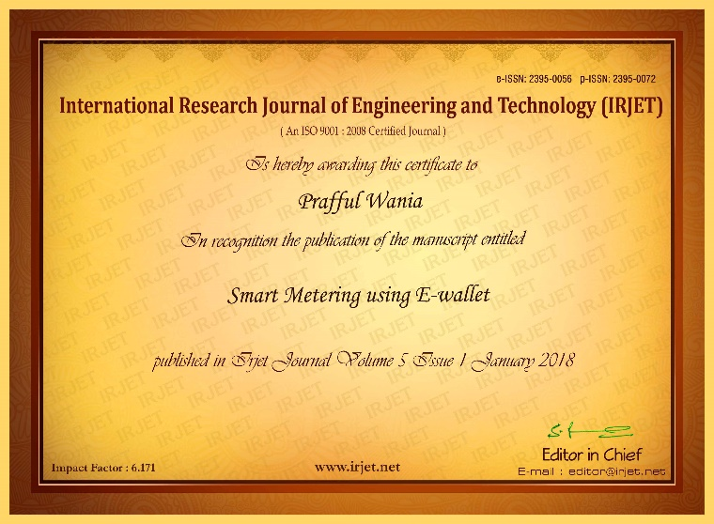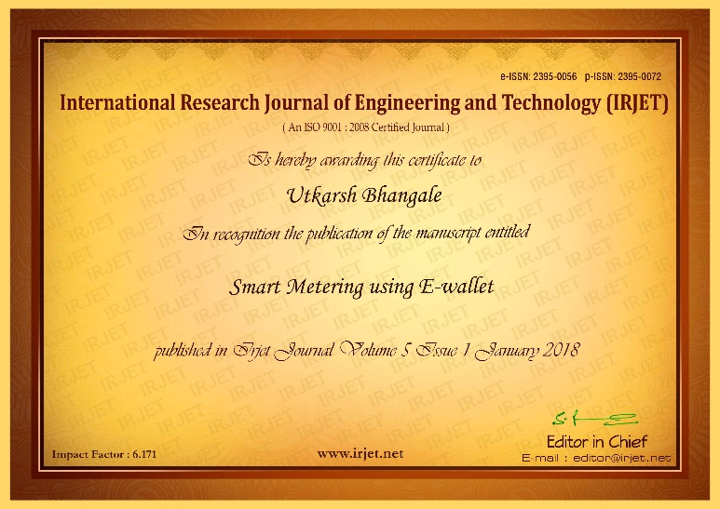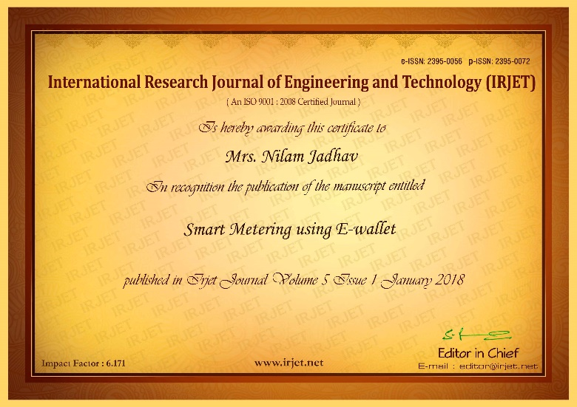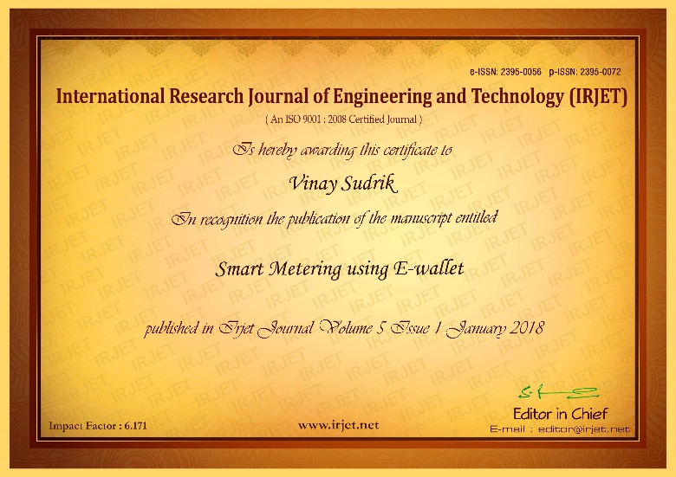

**ANNEXURE B**

**Annexure B**

**Installation Steps:**

* **Installing Arduino Nano:**

When the download finishes, proceed with the installation and please allow the driver installation process when you get a warning from the operating system.

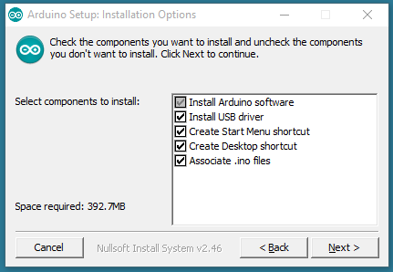

Choose the components to install

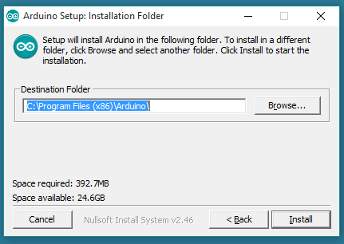

Choose the installation directory (we suggest to keep the default one)

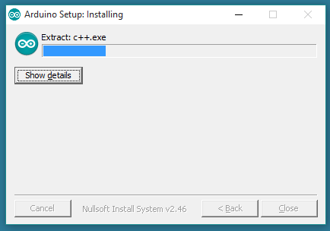  
The process will extract and install all the required files to execute properly

the Arduino Software (IDE)

**Proceed with board specific instructions:**

When the Arduino Software (IDE) is properly installed you can go back to the Getting Started Home and choose your board from the list on the right of the page.

1. Books: -

|  |
| --- |
| [1] GPS: Theory and Practice, B. Hofmann-Wellenhof et al., Springer Verlag, 1992, ISBN 3-211-82364-6  and 0-387-82364-6.  [2] Smart Metering Design and Applications Authors: Weranga, K. S. K, Kumarawadu, Sisil, Chandima, D. P. |

1. Web Links: -

* <https://en.wikipedia.org/wiki/Smart_meter>
* <https://www.thebalance.com/pros-and-cons-of-smart-meters-1182648>
* <https://www.smartenergygb.org/en/about-smart-meters/what-is-a-smart-meter>
* <http://ieeexplore.ieee.org/document/5699358/>
* <http://www.ijcaonline.org/research/volume133/number8/rastogi-2016-ijca-907903.pdf>

1. Paper/Journals: -
2. X. Yu, C. Cecati, T. Dillon, M. G. Simoes, "New frontier of smart grids", IEEE Ind. Electron. Mag., vol. 5, no. 3, pp. 49-63, Sep. 2011.
3. M. Kezunovic, "Data analytics: Creating information and knowledge", IEEE Power Energy Mag., vol. 10, no. 5, pp. 14-23, Sep./Oct. 2012.
4. D. Alahakoon, X. Yu, "Advanced analytics for harnessing the power of smart meter big data", Proc. IEEE Int. Workshop Intell. Energy Syst. (IWIES’13), pp. 40-45, Nov. 2013.

**ANNEXURE C**

**Annexure C**

**TESTING TOOLS AND TECHNIQUES**

* MQTT - MQTT stands for MQ Telemetry Transport. It is a publish/subscribe, extremely simple and lightweight messaging protocol, designed for constrained devices and low-bandwidth, high-latency or unreliable networks. The design principles are to minimize network bandwidth and device resource requirements whilst also attempting to ensure reliability and some degree of assurance of delivery. These principles also turn out to make the protocol ideal of the emerging “machine-to-machine” (M2M) or “Internet of Things” world of connected devices, and for mobile applications where bandwidth and battery power are at a premium.
* Digital Storage Oscilloscope - Check signal integrity, power supply glitches, timing of various events etc. A digital storage oscilloscope (often abbreviated DSO) is an oscilloscope which stores and analyses the signal digitally rather than using analog techniques. It is now the most common type of oscilloscope in use because of the advanced trigger, storage, display and measurement features which it typically provides. The input analogue signal is sampled and then converted into a digital record of the amplitude of the signal at each sample time. The sampling frequency should be not less than the NY Quist rate to avoid aliasing. These digital values are then turned back into an analogue signal for display on a cathode ray tube (CRT), or transformed as needed for the various possible types of output—liquid crystal display, chart recorder, plotter or network interface.